Cruz, John Marley N. BSIT – 4PACED
Co, Johndel M. SEPT, 16 2026
https://github.com/Marlsley/palengke-ledger-solidity.git
10. Sepolia Etherscan Contract URL: https://sepolia.etherscan.io/tx/0x7f19ba1b56d970619bae800e1f4f7bb5b1a4ce97e875ec9b6dccb2aa26e833e8
Sepolia Etherscan recordSale() Transaction URL: https://sepolia.etherscan.io/tx/0x4e6ee7af8c8f4b41f9df89183533421c01ebf0ba16f82e3f473d1387623ebcdd
PART COMPLETE CODE AND CONNECT TO META MASK
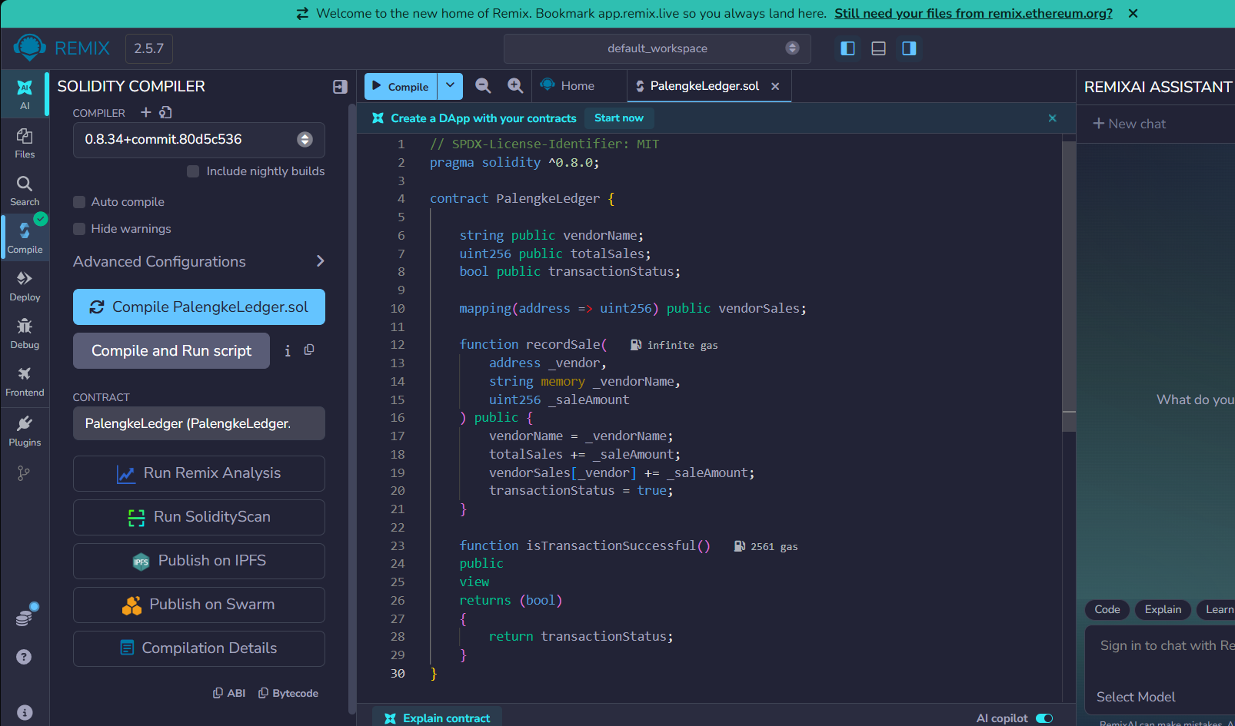
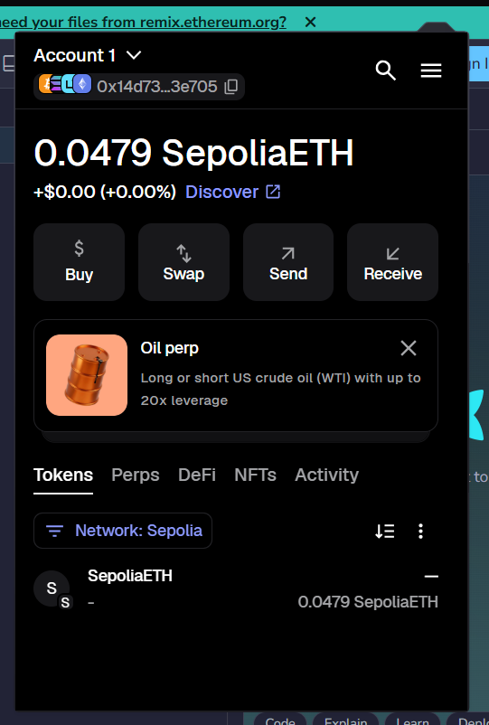

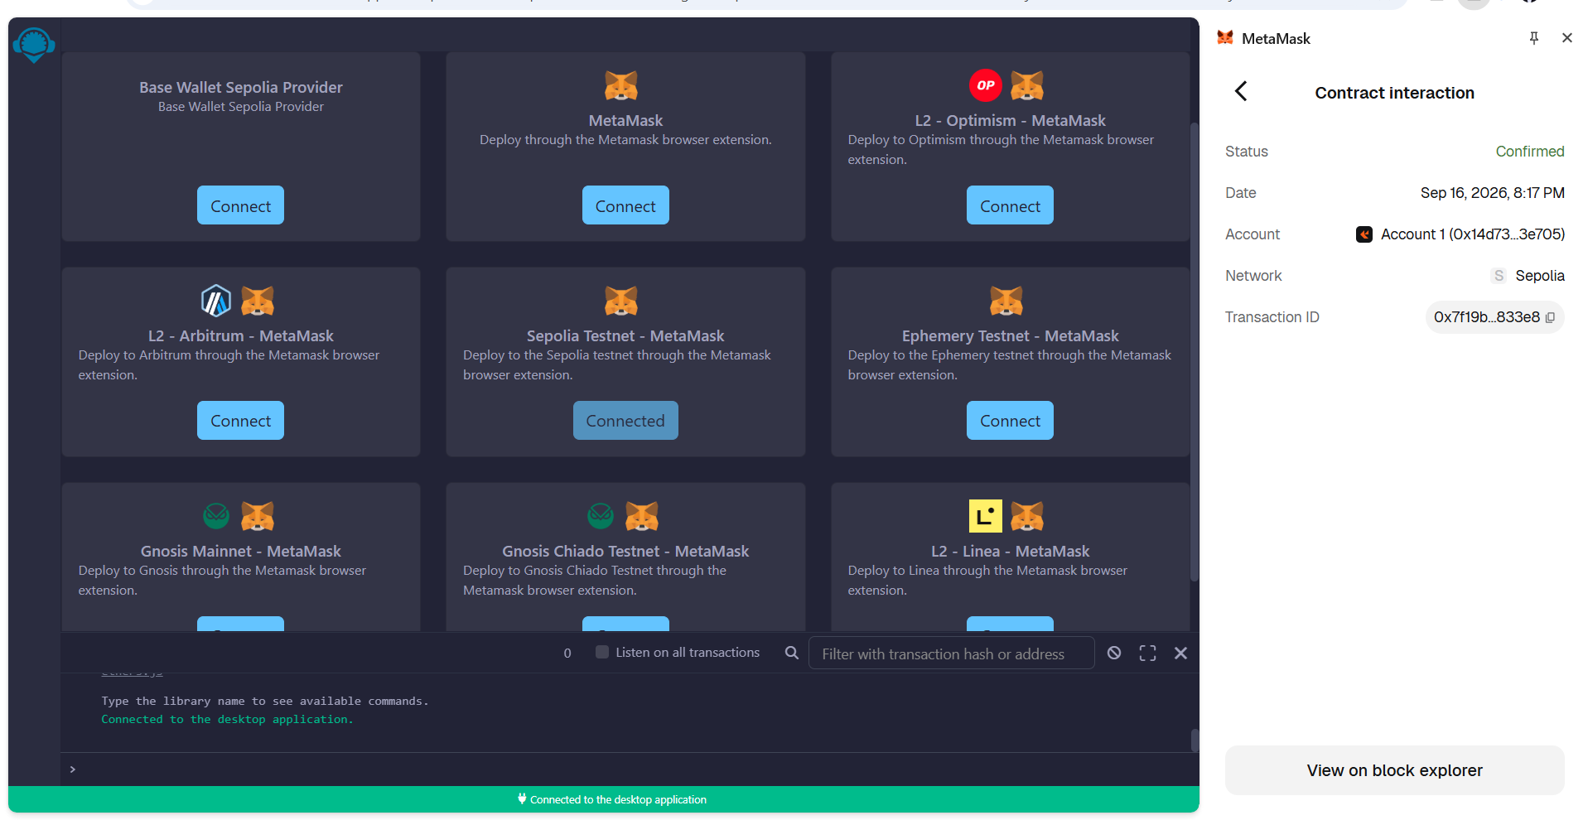

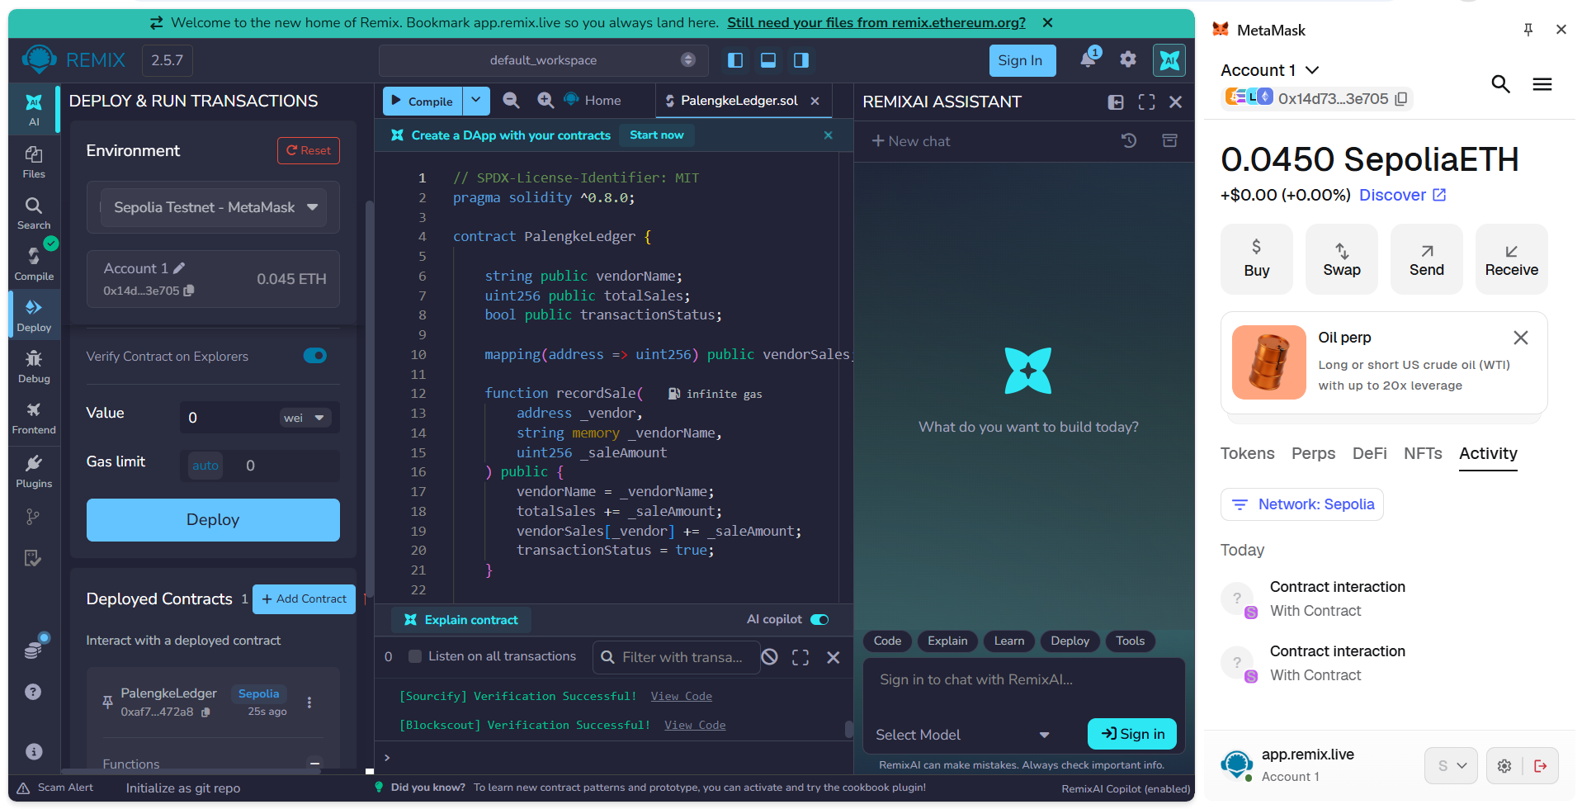

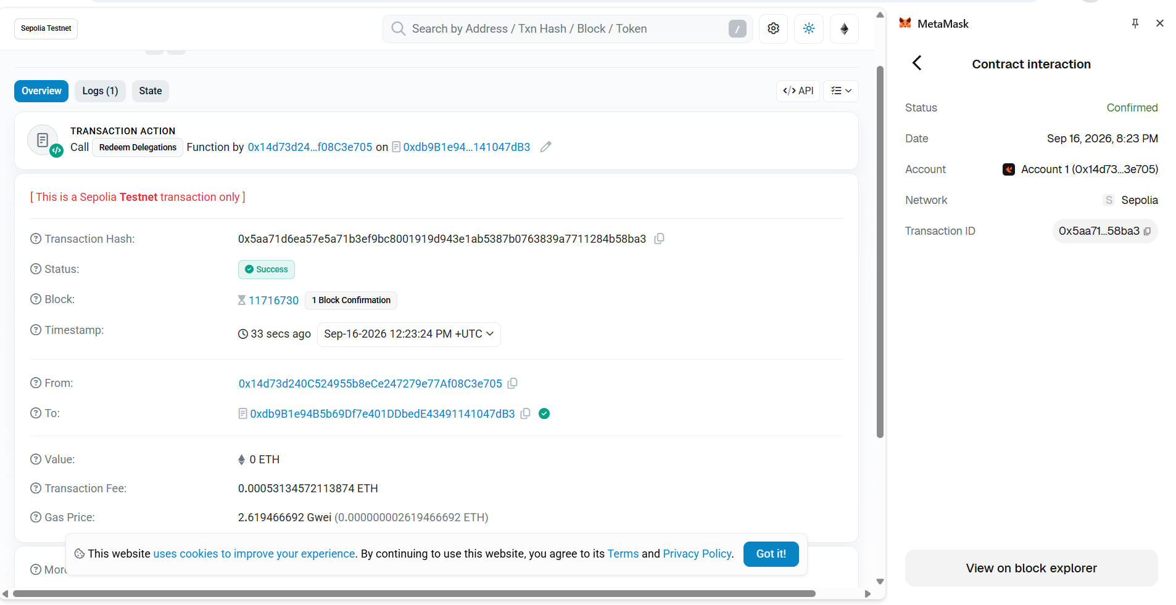

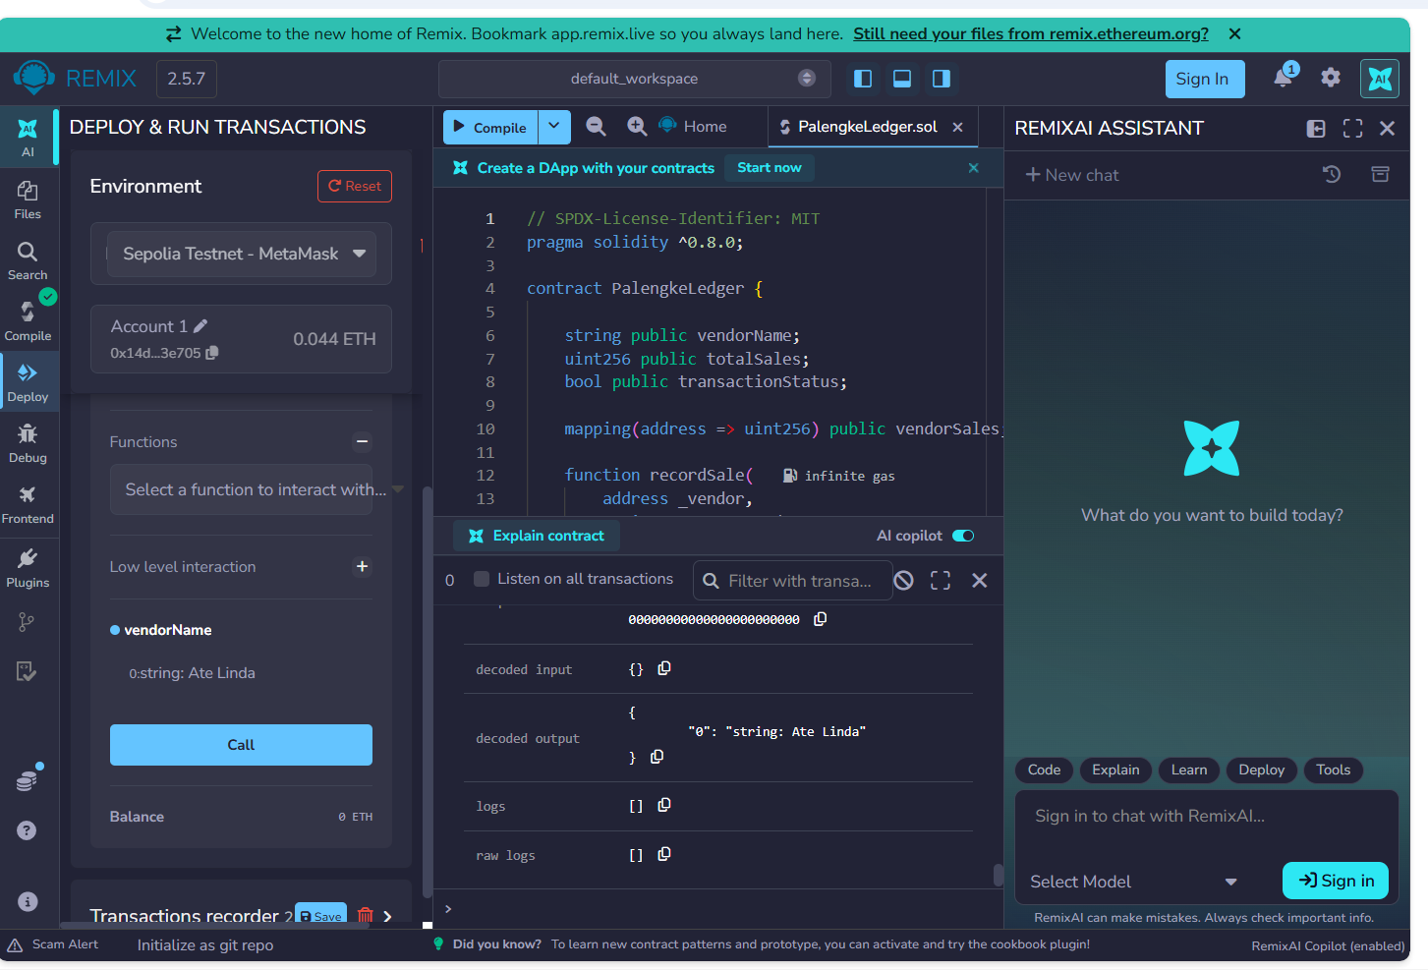

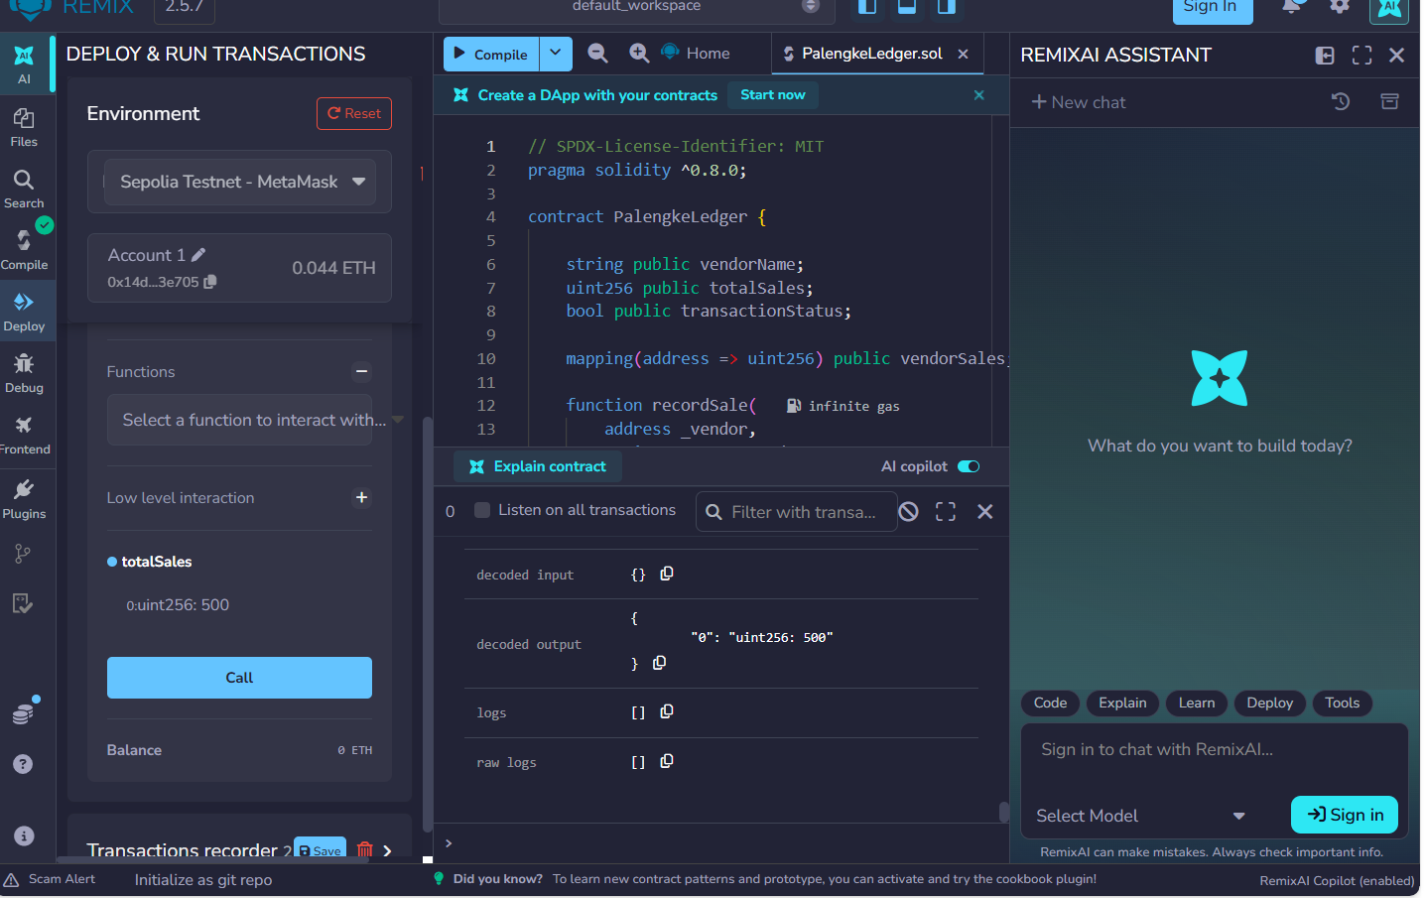

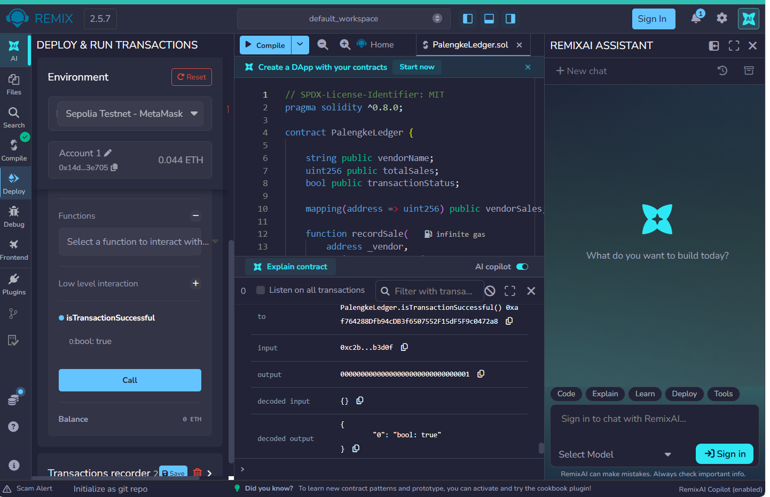
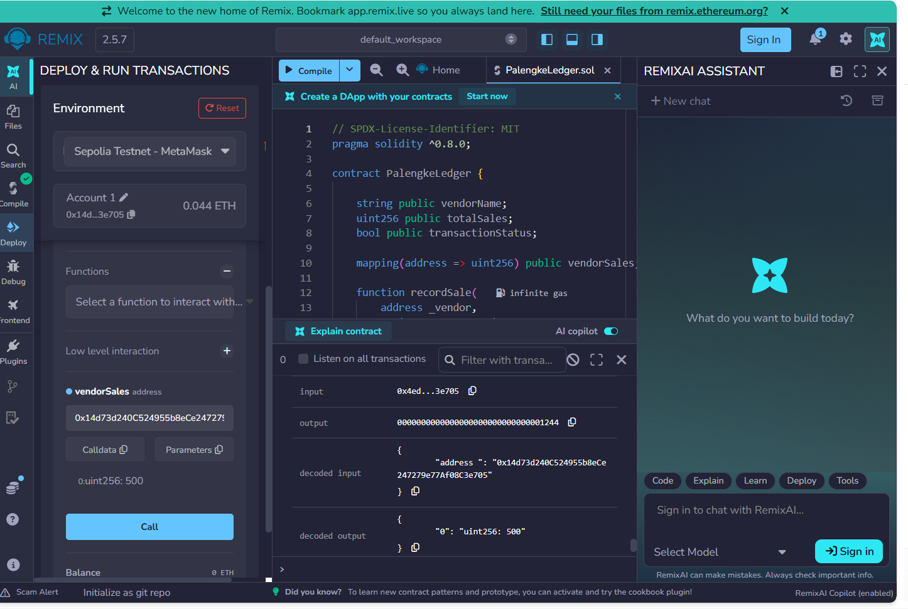

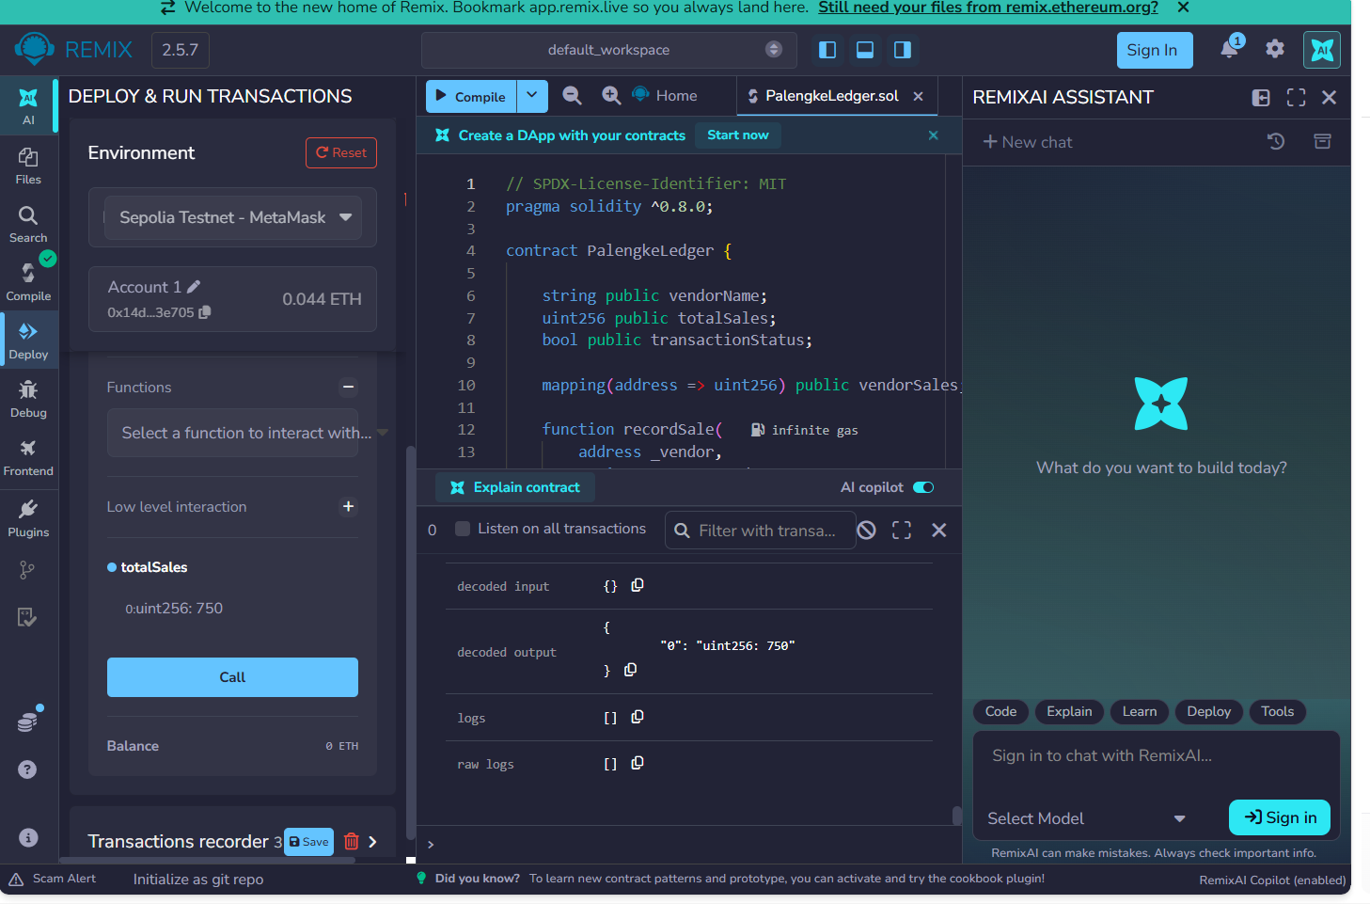

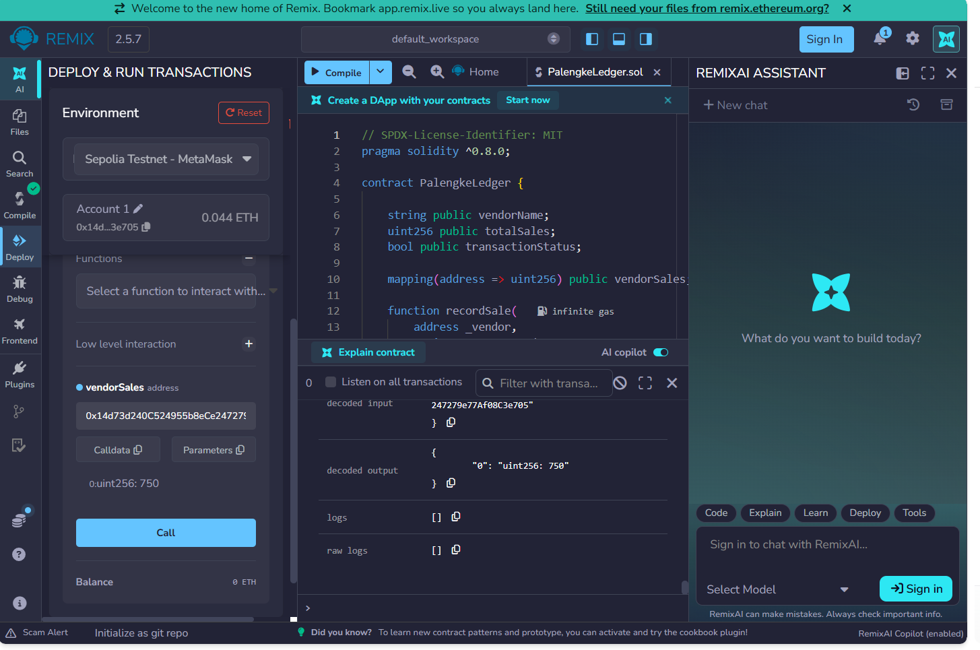

PART OF TRYING MULTI VENDORS:
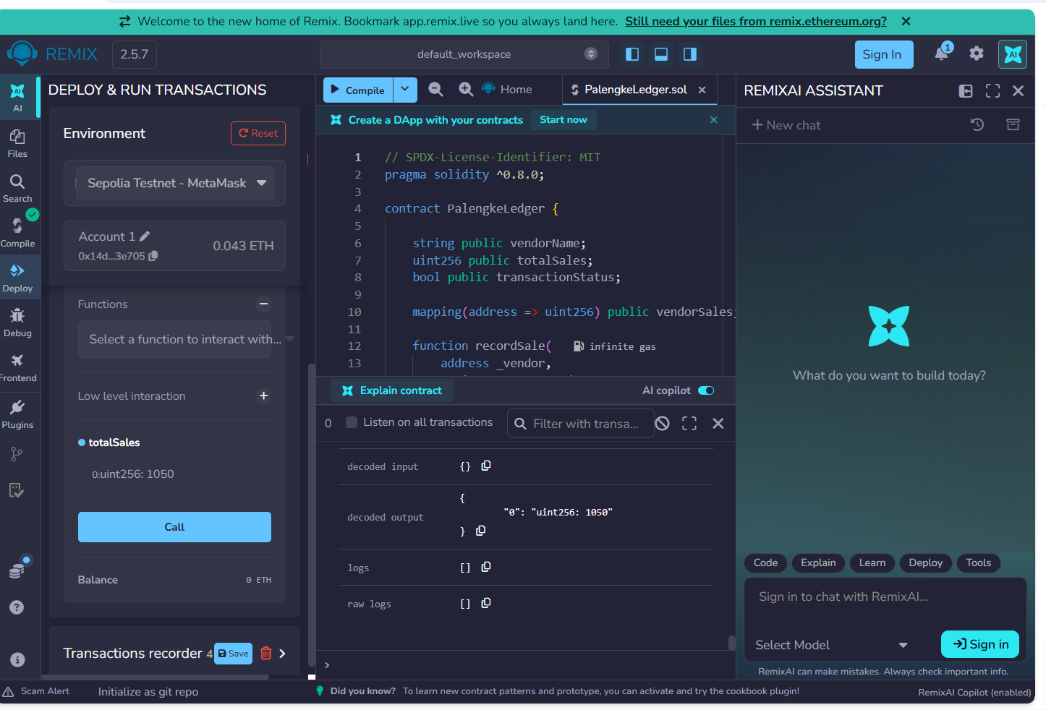

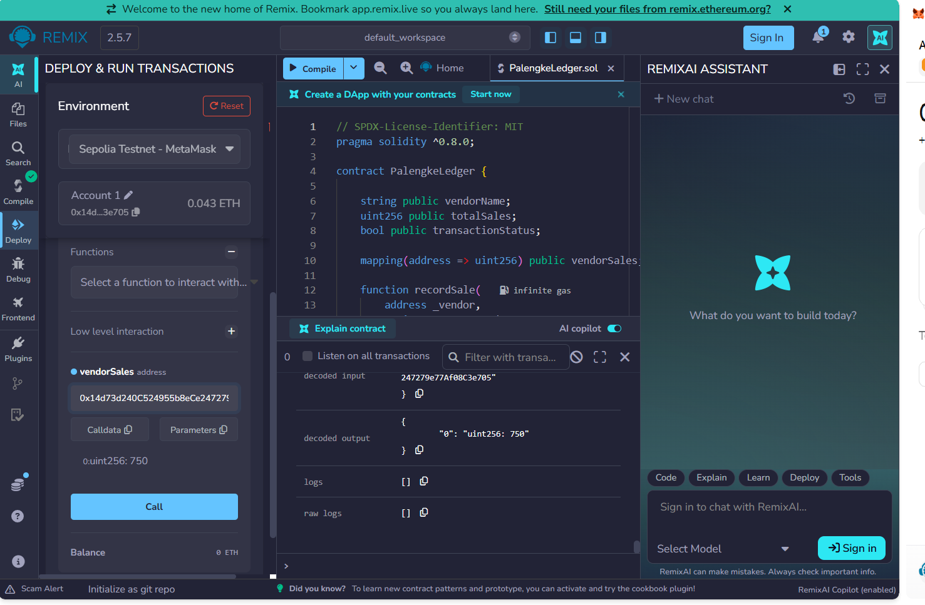

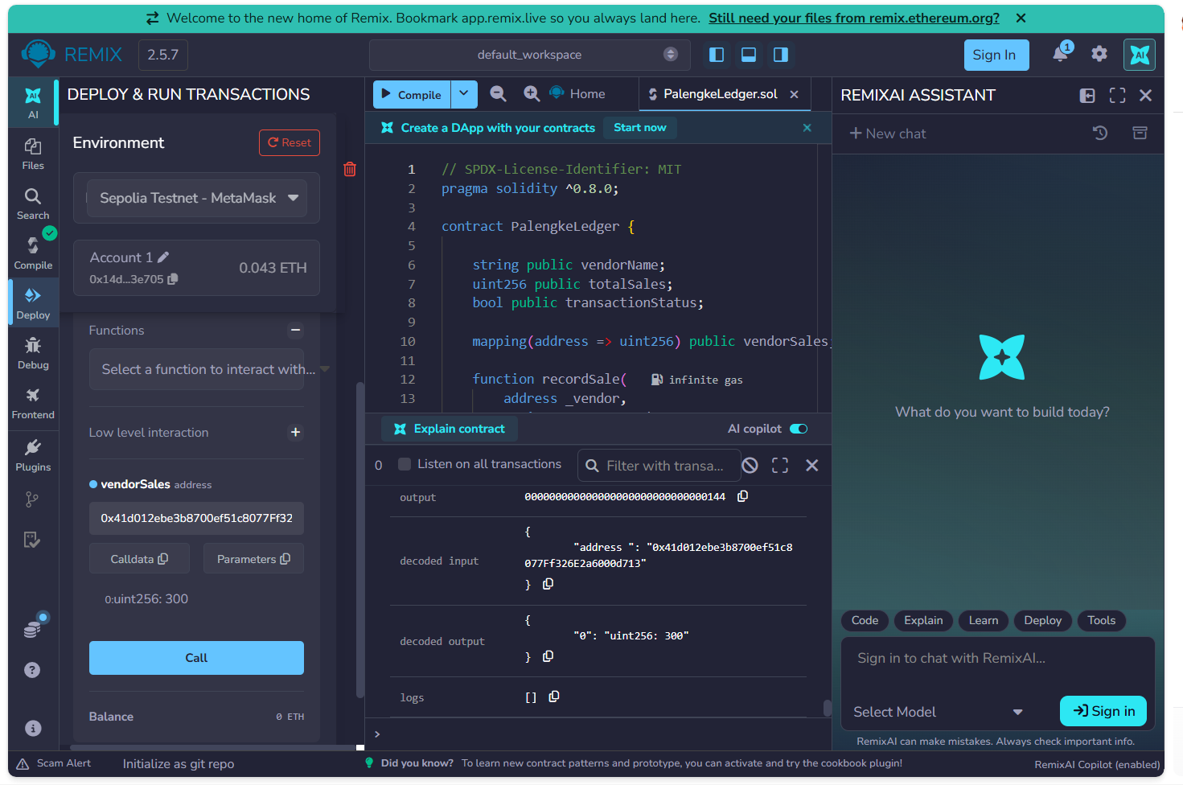
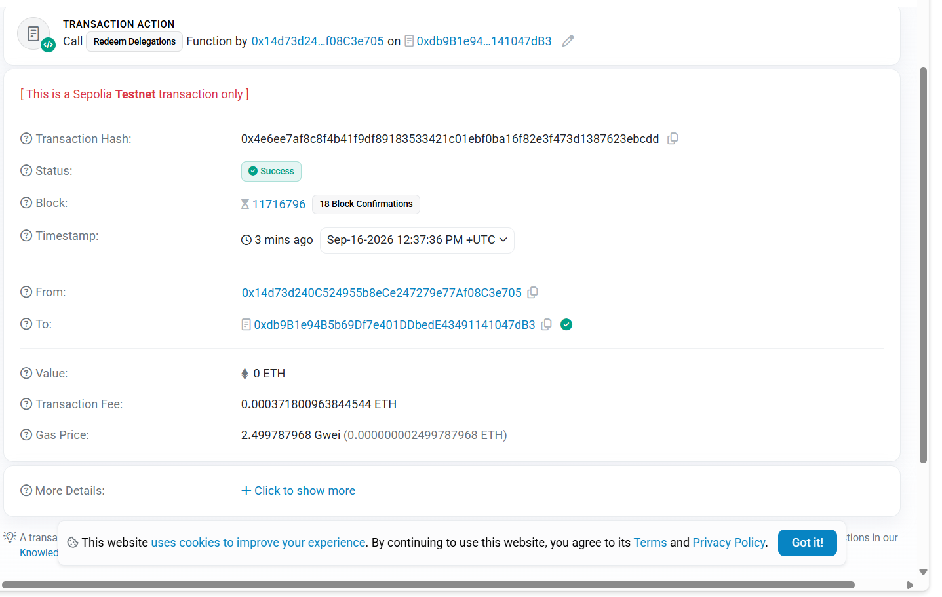

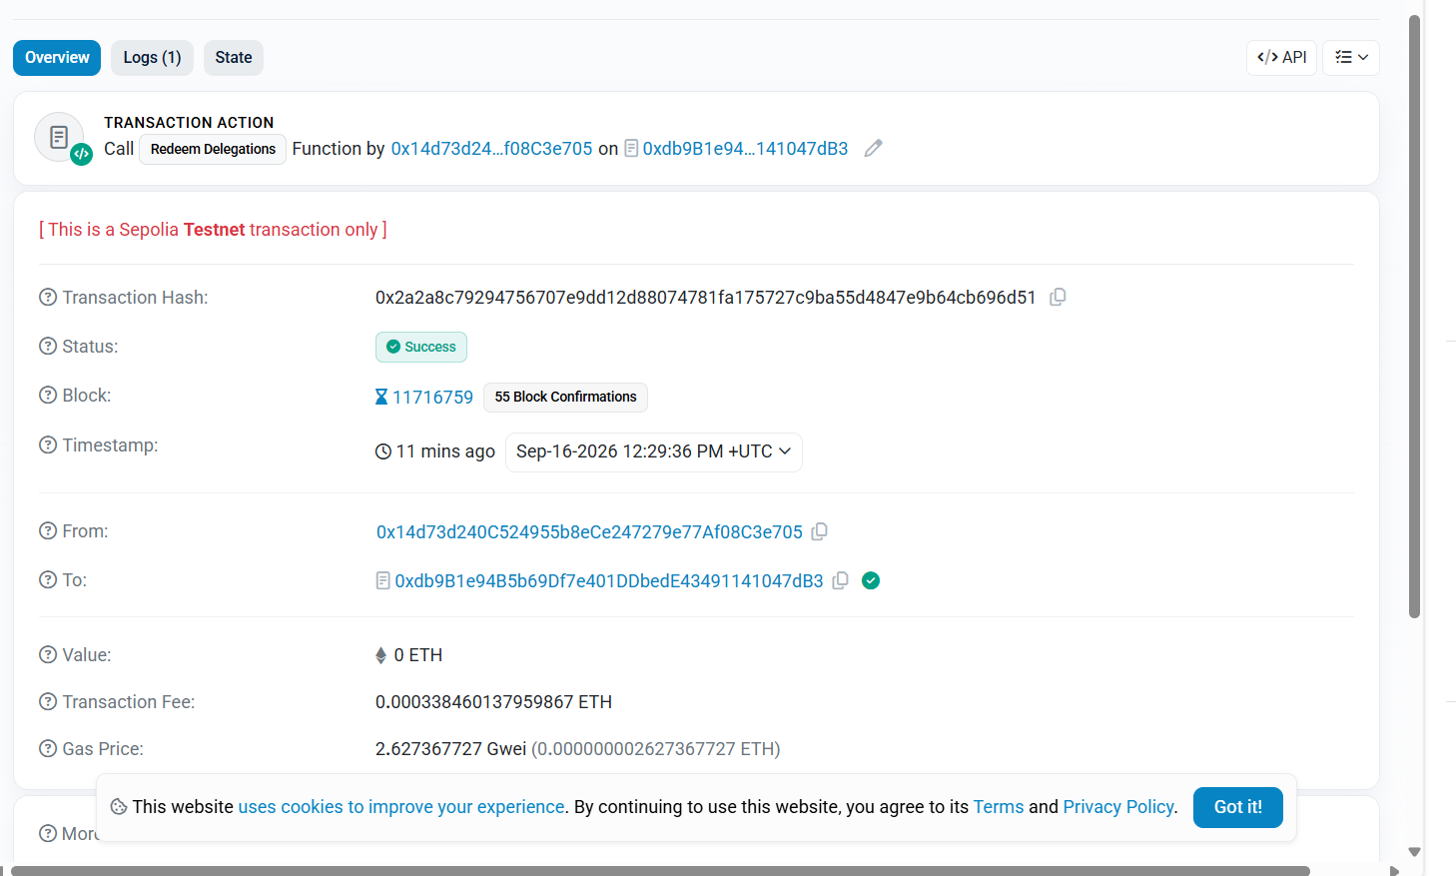

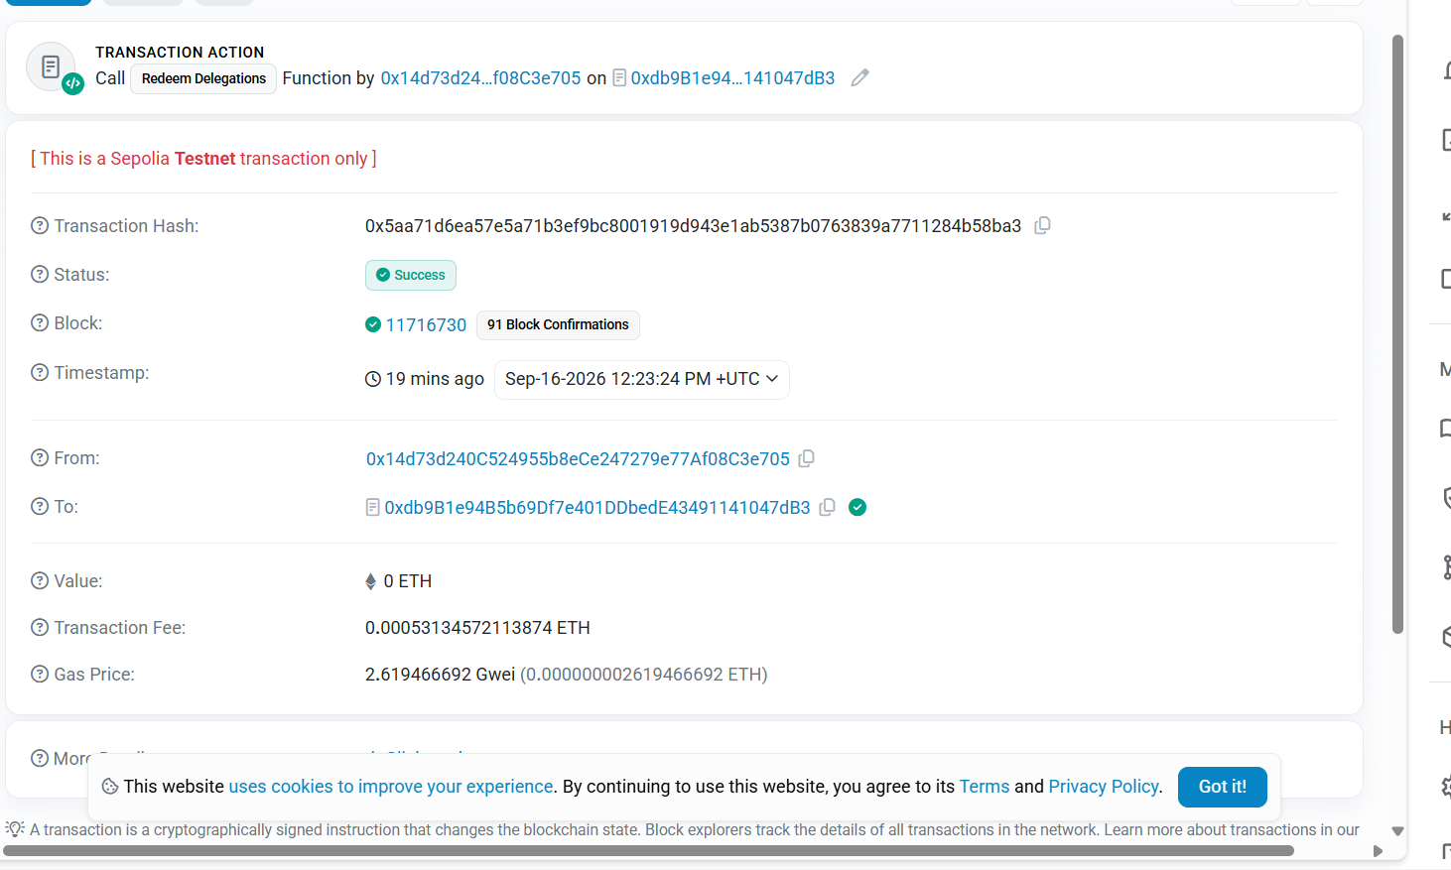
Question 1 – 14 Answer:
Question 1. Why is string appropriate for vendorName?
Answer: string is appropriate because the vendor's name is text, such as "Ate Linda" or "Mang Jose".
Question 2. Why should totalSales use uint256 instead of int256?
Answer: uint256 is appropriate because sales amounts cannot be negative. It stores only non-negative whole numbers.
Question 3. What are the only two possible values of transactionStatus?
Answer: true and false.
Question 4. What is the key of the mapping?
Answer: The key is the vendor's wallet address (address).
Question 5. What is the value stored for each key?
Answer: The value is the vendor's accumulated sales amount (uint256).
Question 6. Why is a wallet address useful for distinguishing vendors?
Answer: A wallet address uniquely identifies an Ethereum account, allowing the contract to keep separate sales totals for different vendors.
Question 7. Why is this function declared view?
Answer: It is declared view because it only reads the transactionStatus value and does not modify the blockchain state.
Question 8. Does calling this function change blockchain data?
Answer: No. Calling isTransactionSuccessful() only reads the current value of transactionStatus.
Question 9. Why is totalSales initially 0 even though the contract never explicitly assigns 0?
Answer: Solidity automatically initializes an unsigned integer (uint256) to its default value of 0.
Question 10. Why did the previous 500 become 750 rather than 250? Identify the Solidity operator responsible.
Answer: The previous value was 500, and the new sale of 250 was added to it, resulting in 750. The operator responsible is the += addition-assignment operator.
Question 11. Once recordSale() is confirmed on Sepolia, why can't the student simply remove that blockchain transaction?
Answer: Once the transaction is confirmed on the blockchain, it becomes part of the blockchain's historical record. The student cannot simply delete or remove the confirmed transaction.
Question 12. Does blockchain immutability mean that totalSales can never change? Explain the difference between changing contract state through another valid transaction and altering an already-confirmed historical transaction.
Answer: No. totalSales can change through another valid transaction, such as calling recordSale() again. However, an already-confirmed historical transaction cannot simply be altered or deleted.
Question 13. Why should vendor sales not be stored independently inside separate application web servers if an application uses multiple servers?
Answer: Because separate servers could have different copies of the sales information, which may cause inconsistencies or disagreements. A blockchain provides a shared transaction record that can be accessed and verified consistently.
Question 14. What information can Etherscan provide that helps demonstrate that the transaction actually occurred?
Answer: Etherscan can provide information such as the transaction status, transaction hash, From address, contract address, and transaction details, which can be used to verify that the transaction occurred on Sepolia.

